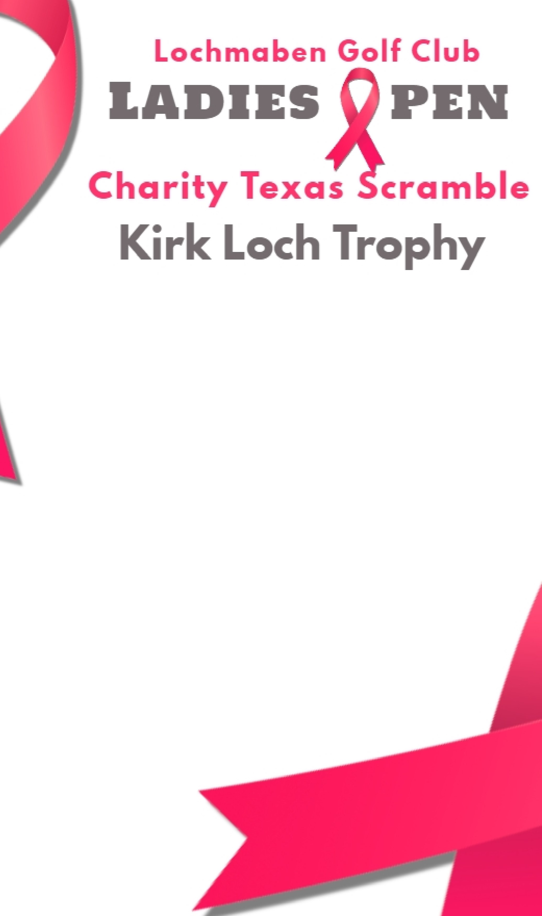

**17TH Anniversary of Charity Pink Golf Day**

**Raising funds for local Breast Cancer Care**

**HHHH**

**FRIDAY 4TH OR SATURDAY 5TH JULY 2025**

**Kirk Loch Trophy – Handicap Prizes**

**Prizes:**

•

The Competition will be a Stroke Play Competition played over 18 Holes.

•

The Competition will be open to teams of 4; all ladies,

**Full Members**

of a recognised

golf club and of amateur status, Age 14+.

•

Maximum Competition Handicap allowed is

**27.**

•

**Total Entry Fee is**

**£50**

**per team**

Tee times 08.00 – 15.00.

•

**ONLINE BOOKING ON WEBSITE**

•

**Numbers may be restricted.**

•

Ties for the trophy will be decided according to the results over the last 9, 6, 3 or the last

hole.

•

The Committee of Lochmaben Golf Club reserves the right to reject any entry and to

alter and amend any of the conditions. The decision of the Committee in matters of

dispute shall be final.

•

Website:

[www.lochmabengolf.co.uk](http://www.lochmabengolf.co.uk/)

email address:

enquiries@lochmabengolf.co.uk

•

Limited Number of BUGGIES AVAILABLE FOR HIRE by phoning Clubhouse

**Closing Date for Entries is 31 May 2025**

**Please Wear Pink**